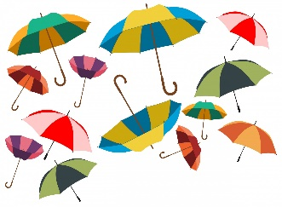
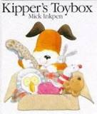
Year 1 Spring term 1 2023
Welcome back after the Christmas holidays! This half term we are looking at toys as our topic. We will be looking at changes seen in our lifetime by looking at toys and teddies. We will use some familiar texts in literacy linked with this topic e.g Kipper’s Toybox, Goldilocks and the Three Bears, Traction Man and Toys in space. In English we will be writing instructions, Missing posters, party invitations, letters and descriptive sentences. In grammar we will begin to use conjunctions in our sentences by putting sentences together with “and”, “but” and “or”.
The Science topic for this term is “Materials” and we can use this to look at toys and in particular an investigation into the most suitable material for Teddy’s umbrella. We would encourage you to talk at home and while out and about with your child about what things are made out of and why, thinking about the properties of materials that make them suitable for certain purposes.
In Maths we are looking at Place Value to 20, addition and subtraction with numbers to 20, using counting on and number lines. We shall be measuring using standard and non-standard measures for height, weight and capacity. You can help your child by providing opportunities for them to add and take away using coins, pasta, or any other counters and encouraging them to make their own number lines on paper on with chalk outside.
The RE topic covers Special People both in our community and our church. You may find it helpful to talk about why people are special and how we can all play a part in our community and church. The second RE topic is Special Meals and we will look at the Last Supper as a special meal that Jesus shared with his Disciples and we continue to share in at the Eucharist in church.
The topic homework for this half term is to make a toy or game for our class toy museum. Please bring this in by 6th February.

I also encourage you to help your child’s reading and phonics progress further and check out these phonics sites.
Phonicsplay.co.uk (choose free play activities) bbc bitesize phonics activities https://www.topmarks.co.uk/english-games/5-7-years/letters-and-sounds http://www.galacticphonics.com
Many thanks
Mrs Crowley

