Year 1 Lent term 2 2023
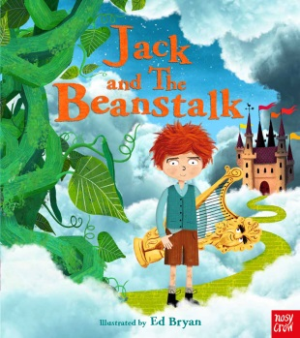
Our topic this half term is Giants and Beanstalks. We will be using “The smartest Giant” by Julia Donaldson and “Jack and the Beanstalk” as our main texts this half term in our writing and using them to write letters. Please show your child any letters you might get (I know we don’t get many in these days of digital media!) as they might not be familiar with the format of a letter.
“Jack and the Beanstalk” will also help us in our Science topic of Growing plants. During Spring lots of plants will begin to grow in our gardens and parks so we will be looking at what plants need to grow and how the process takes place. If you are particularly green fingered then you might want to plant some seeds and small plants and discuss this process at home!
In maths we will begin to look at multiples of 2, 5 and 10 moving on to measurement of length, height, weight and volume towards Easter. You can help your child by practising their counting through songs and rhymes. Super Movers by the BBC is a great site for some of these ideas. We have also set your child up on an interactive site called Times Tables Rock Stars.
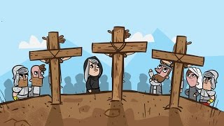
Our RE topic this half term moves us from Special Meals toward Easter as we think about changes. This will be reflected in our Science topic and in our writing work as we consider the changes that happen around us and within us.

World book day – Friday 3rd March. As a whole school we will be celebrating World book day by dressing up and talking about books separate details about this have already been on Whole school Class Dojo.
Class trip to Newarke Houses museum- Monday 27th March
Many thanks Mrs Crowley

