Year 1 Advent term 1 2022
Welcome to Year 1!
I hope that you have enjoyed your summer and are excited about learning new things together in year 1.
Our first topic is “Oi Animals!” Where we will cover key aspects of the English curriculum, including writing in books, spacing for words and beginning to write sentences. We will use our English skills as we cover aspects of Science by looking at and comparing a variety of animals and humans. Please repeatedly refer to the Key learning sheet sent home with your child. We will explore the topic using the stories: Oi Frog by Kes Gray, Elmer the Elephant by David McKee, The Mixed up Chameleon by Eric Carle and Handa’s Surprise by Eileen Browne. It will help us to look at how we are all special and unique and to celebrate our differences, as well as looking at what makes us similar to other animals. We will finish the topic with an Animal themed day, where we will take part in a variety of activities such as Art, Dance, and drama. Homework project – find out and present some facts about an animal of your choice. This can be a poster, drawings, or powerpoint but must be your child’s own work. Bring this project in during the week before half term.
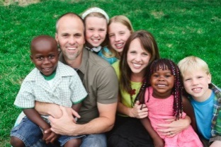
Families and Belonging
The first two RE topics link nicely together and fit into our overall theme as we look at what it means to be part of our own family and God’s family, before exploring how we can belong within those families and in other areas of our life, such as in sports clubs and uniformed organisations. Please talk to your child and share memories and experiences of wider family times. We will encourage them at certain points to share their experience of belonging to groups and organisations outside school.
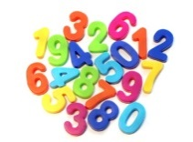
Maths
In maths we will be looking at Place value and addition and subtraction. Any practice you can do with your child at writing, reading and counting numbers up to 20 will help them.
Homework
In year 1 we will work towards weekly homework in special homework books which will be sent home each Tuesday and aredue to be returned, the following Monday. This will usually consist of a handwriting practice and a number or literacy activity. This will not begin immediately, as we want the main concentration to be reading with your child. We expect you to regularly listen to your child read and initial the link book accordingly (books will be changed once a week if they have been read). Within a few weeks we will start to send home spellings. This will have a short list of spellings for your child to learn at home. There will be a spelling test the following week. There is also one piece of ‘project type’ homework, each half term either set by us, or as whole school homework.
Finally, a quick reminder that PE is on Monday and Friday. The children are asked to come in joggers, a polo shirt and to have their pumps, shorts and PE t-shirt in their PE bag at school.
I can be contacted via Class Dojo, or the school office if you have any concerns or questions.
Many thanks Mrs Crowley

