EYFS FIRST ADVENT TERM LETTER 2021
Dear Parents/Carers
We would like to welcome all our new parents to St Peter’s and hope you will enjoy being part of our school community. The children have done so well coming into school this term, bearing in mind they didn’t have the transition days in the Summer Term. Well done! However, if you have any worries regarding your child we are always available at the end of each day.
You will have received a letter introducing you to Dojo. This is an online learning/communication platform which we will use for messages between home and school. More information about this will follow shortly. Please ensure that you have logged on both as a parent and for your child.
These first few weeks for the children are all about settling in and getting to know each other. The staff will be assessing the children to form a baseline, before planning a curriculum.
Topics 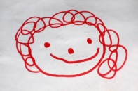
Our first topic is, ‘ Myself.’ We will be looking at what we like doing and how God made us all different and all special. We will also be looking at ‘Animals’, incorporating the ‘Noah’s Ark’ story and finally learning ‘All About Autumn’ before breaking up for half term.
Reading and Phonics
Your child will be bringing home a book to share with you and some character name cards and words to learn.
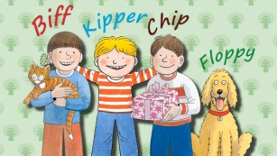 When you have shared the book at home with your child, we would be grateful if you could indicate on your child’s reading card inside the book. Your child will be given books and or words to practice at home. Once your child has learnt the set of words, they will be given a set of books with these words in.
We will be having a Phonics ‘Workshop’ on Wednesday 29th September. We strongly urge you to attend this meeting, which will help you to support your child with their reading and phonics at home.

P.E.
P.E. will be on Tuesdays and Thursdays. Please send your child into school in their school joggers on those days. If you haven’t already, please send your child’s PE kit into school.
Food and Drink
Fruit will be provided during the school day and we ask that you provide a small water bottle for your child. Lunch is provided and we suggest you, ‘ give them a go’, before sending your child in with sandwiches.
Clothing
As you are aware EYFS includes outdoor learning, so the children do spend some time outside every day, whatever the weather! So please can you be sure to send your child with a cardigan or jumper every day and a coat when the weather becomes less predictable!
Miss Baker and Mrs L. Swinfield

