GEOGRAPHY - USA Road Trip
Key vocabulary and definitions

Continent | The seven world land masses: Africa, Asia, North and South America, Europe, Australasia and Antarctica. | Washington | The capital city of the USA
N.and S. Hemisphere | The two halves of the globe separated by the equator. | Congress and Senate | The political system in the USA
States | Legally independent areas which join together to form the United States of America | Mississippi | The longest river in the USA
Native Americans | The indigenous people of North America | Fast food | Easily prepared processed food in snack bars and to take away.
European Colonists | People from Europe who settled in North America | Landmarks | Famous buildings or natural features eg. The Statue of Liberty, Mount Rushmore and the White House.
Stars and Stripes | The design of the American flag- sometimes called The Star Spangled Banner | Thanksgiving | An American holiday celebrated at the end of November
The White House | The official residence of the President of the USA in Washington DC | 4th July | American Independence Day
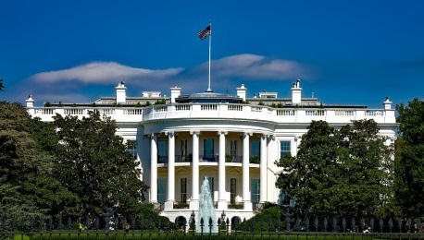
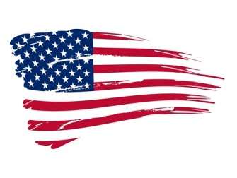

- Thanksgiving and The Mayflower
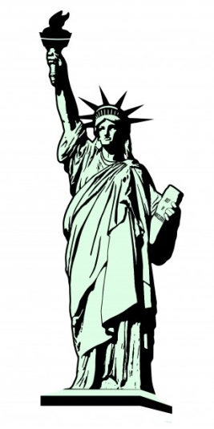
- The States of the USA
- Native Americans and their culture
- New York! New York! A tour of the Big Apple.
- The Mississippi River and New Orleans
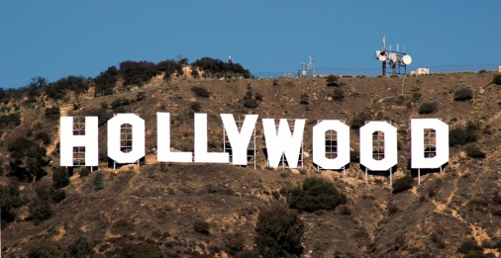
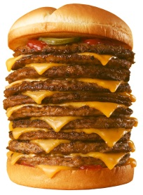
- The Great Lakes and Chicago
- Music of the USA
- Florida and Theme Parks
- Fast Food

