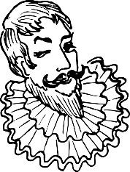
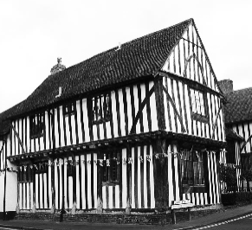
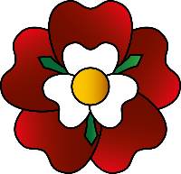
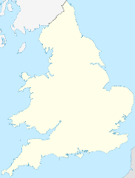
The Tudors
England and Wales
(Europe)
1485 | 1509 | 1534 | 1542 | 1558 | 1577 | 1585 | 1591 | 1603
Battle of  Bosworth / Henry VII King of England | Henry VIII reigns | Henry VIII forms the Church of England | Mary Queen of Scots lays claim to the throne | Elizabeth I Queen of England | William Drake sails around the world | England and Spain at war | First performance of a Shakespeare play | James of Scotland first Stuart King

 | Key Vocabulary
exploration | The lure of wealth led to explorers searching for new routes to Asia and new discoveries along the way.
Armada | A fleet of warships. The Spanish Armada was sent by Philip II of Spain to launch an invasion of England in 1588.
The Globe | A three-story, circular Elizabethan theatre in London built by Shakespeare’s playing company in 1559.
Hampton Court | A large royal palace in London built for Cardinal Wolsey in 1515 but eventually handed to Henry VIII.
Civil War | A war between two or more groups in the same country.
monarch | A sovereign head of state (king, queen or emperor).
peasants | Most would only afford one meal a day, finding work was tough and the average life expectancy was 35.
Protestant | Being Roman Catholic was most common in Tudor times until a German monk spread the idea of a different way.
Reformation | An attempt to turn the church from Catholic to Protestant.
Excommunicate | To banish someone from membership of the Church

Henry VIII (1491-1547)
Most famous for having 6 wives with their fate remembered best by the rhyme ‘Divorced, beheaded, died, divorced, beheaded, survived.’ His second wife Anne Boleyn gave him a daughter (who later became Queen Elizabeth I) before he executed her in 1536. He broke away from the Catholic Church claiming himself at the head of the Church of England but was also well-known for being athletic, good-looking, intelligent, speaking many languages and playing musical instruments.

Elizabeth I (1533-1603)
Initially the Catholic Church said Henry and Anne were not lawfully married so she should not be Queen and Mary Queen of Scots should be Queen instead. Elizabeth found out several plots to overthrow her and had Mary executed in 1587. In 1588 the King of Spain sent the Spanish Armada (a fleet of ships) to take England. Elizabeth won the war and it was seen as a great victory. She had no children of her own so the throne went to King James of Scotland (Stuarts begin and the Tudors end).

William Shakespeare (1564-1610)
The famous writer and actor performed several times for Elizabeth I and wrote many famous plays including Romeo and Juliet, Macbeth and Hamlet.
Tudor towns and villages were not particularly clean and tidy. People threw rubbish in the street and even emptied the loo there! It was a very smelly time to exist!

The Tudor Rose
The Tudor rose was created when Henry VII brought an end to the Wars of the Roses (an ongoing battle between two royal groups – the House of Lancaster and the House of York). He joined the White Rose of York with the Red Rose of Lancaster, creating the Union Rose (or Tudor Rose), which is still used as the floral emblem of England today!
Tudor Houses
Tudor houses are very distinctive and many can still be seen today. The houses had a wooden frame with walls made from “wattle and daub” – a building material consisting of wooden strips covered with mud, clay and wet soil. The walls were then painted white giving what is known as “the black and white effect”.
Jobs
Jobs that people would have had in Tudor times include being a butcher, baker, weaver, fishmonger (catching and selling fish), tailor, blacksmith, shoemaker and washerwoman.
Music
Music was very popular in Tudor times, and it was a large part of entertainment both in the royal court as well as for the peasants. It also meant that somebody from any class – rich or poor – who was good enough at an instrument could have the chance to play for the king or queen! Musical instruments played include the viol, hautboy, harpsichord and spinet.

General Knowledge
Famous Figures

