. Heat proud

***Thermal Insulators*** – Do not let heat travel through easily such as fabrics, wood and plastics. Can keep heat in or out.

***Thermal Conductors -*** Lets heat travel easily through such as metals.

When things get hot, atoms start to vibrate. Heat produces energy. This could cause them to change state!

**Key words**

**Soluble** – something that can be dissolved in water

**Solution** – What is created when a solid is dissolved into a liquid

**Reversible change** - When a solid, liquid or gas can be changed back to its original state of matter.

**Irreversible change** – When a solid, liquid or gas that has been changed, can’t be changed back to its original state.

**DISSOLVING**

Dissolving is when the particles

of solids mix with particles of

liquids, often appearing like it

has disappeared but it has

dissolved in the liquid to make a transparent solution (e.g. mixing sugar into water). It does

not always need heat to occur. If a material does not dissolve it is insoluble. If it does, it is soluble.

**MELTING**

Involves only solids which change into a liquid due to heat. They stay as the same material

(e.g. ice to water)

**Properties and changes of materials**

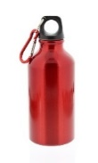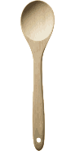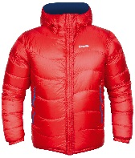

**Three states of matter**

**GAS**: particles far apart and randomly arranged / move around

**LIQUID**: particles close but randomly arranged / move around

**SOLID**: particles very close together / vibrate around a fixed position

[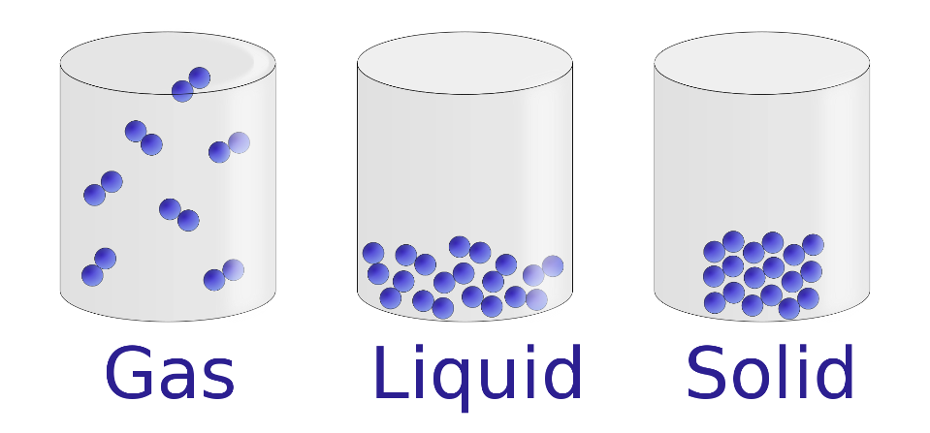](https://www.google.co.uk/url?sa=i&rct=j&q=&esrc=s&source=images&cd=&cad=rja&uact=8&ved=0ahUKEwiHr8T76p3VAhXLtxQKHXEPCUYQjRwIBw&url=https://commons.wikimedia.org/wiki/File:States_of_matter_En.svg&psig=AFQjCNF-fyByJCVK6xDCEy7VB8X76PQzaA&ust=1500845355851131)

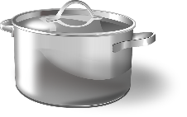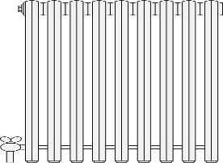

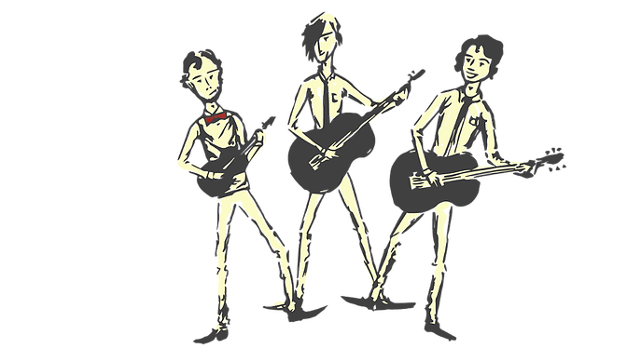

**Three states of matter:**

**SOLID**: particles close together / vibrate around a fixed position

**LIQUID**: particles close but randomly arranged / move around

**GAS**: particles far apart and randomly arranged / move around

**Examples**

Steam (water vapour)

Hydrogen

Carbon Dioxide

Oxygen

**Examples**

Ice

Wood

Glass

Diamond

**Examples**

Water

Milk

Washing up liquid

Juice

**Separating Materials**

**SIEVING** – A way to separate two solids of different sizes (e.g. flour and raisins).

**FILTRATION** – A mixture of liquids and solids which haven’t dissolved can be filtered using paper with tiny holes (e.g. sand and water).

**EVAPORATION** – A solid dissolved in a

liquid (solution) can be heated. Liquid

evaporates and leaves behind the solid (e.g. salt and water solution).

**MAGNETISM** – Metal attracts to the

magnet, leaving behind the other solid (e.g. paper clips and matchsticks).