**LEVERS**

A way to lift heavy weights using

the least amount of effort. The longer the lever, the easier it is to lift. The fulcrum is where the lever pivots in order to lift the heavy load.

**Gravity**

**Gravity** - pulls us down and ensures that unsupported objects to fall back down to Earth.

Famous scientist Sir Isaac Newton discovered gravity when an apple fell on his head.

**Newtons (N)** – The measurement of force.

**Weight** – How much force is pulling you down (N)

**Mass** – How much ‘stuff’ something is made up of (kg) -

The bigger a planet – the more gravitational pull it has

Forces

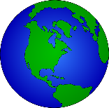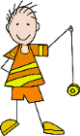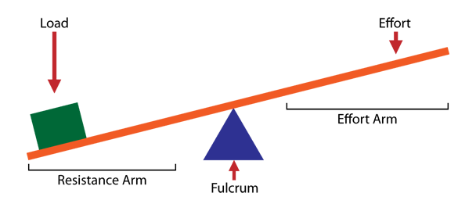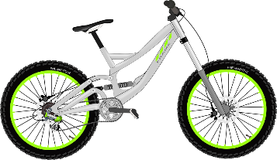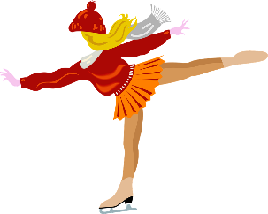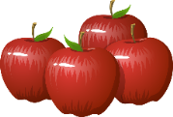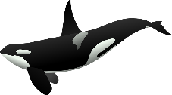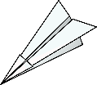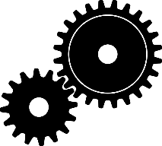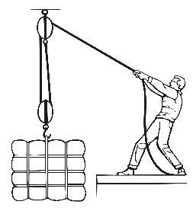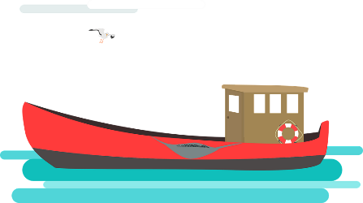

**Friction**

When objects are pushed or pulled, an opposing force can be felt. This opposite force is called ‘friction’. Friction causes things to slow down or stop.

The rougher the surfaces, the greater the friction. This rubbing of two surfaces can release energy, causing heat.

**GEARS** - Used to transmit power from one part of a machine to another. Connected gears can increase speed, increase force or cause a change in direction.

**PULLEYS**

Used like levers to lift loads with less effort but for longer distances. Rope is passed through a pulley which is attached to an anchor point and returned back to the ground to be pulled.

**Air Resistance**

Air resistance (sometimes referred to as drag) acts against gravity on falling or moving objects.

Pushes against an object to slow it down.

**Streamlined shape** – a way to reduce air resistance

**Water Resistance**

Water resistance is a type of *friction* which can slow things down in the water.

**Streamlined shapes** reduce water resistance.

**Upthrust** is the name of the force which keeps things afloat in water. When gravity is greater than upthrust, the object sinks. When the two are the same, the object floats.