Earth and Space
Key vocabulary and definitions

Axis | An imaginary line about which a body rotates | Shadow | The dark area caused when light is blocked by an object
Earth | The planet which we live on | Solar system | The collection of eight planets and their moons in orbit round the sun
Moon | A natural satellite of any planet | Spherical body | The approximate shape of the Earth, Sun and Moon
Orbit | The regularly repeated oval course of a celestial object around a star or planet | Star | A star is a luminous ball of gas, mostly hydrogen and helium, held together by its own gravity
Phases of the moon | How the moon looks at different times of its orbit around the Earth. | Sun | The star round which planets orbit
Rotate | The action of rotating (spinning) about an axis | Tilt | The 23.5 degrees that Earth is angled on
Seasons | Each of the four divisions of the year (Spring, Summer, Autumn, and Winter) marked by particular weather patterns and daylight hours, resulting from the Earth's changing position with regard to the sun. | Waning | Getting smaller
 |  | Waxing | Getting bigger

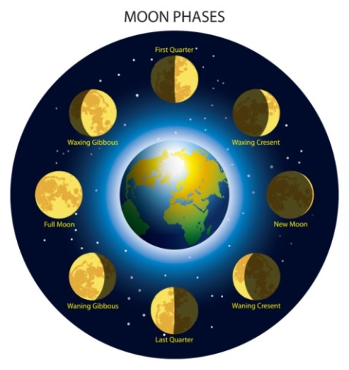
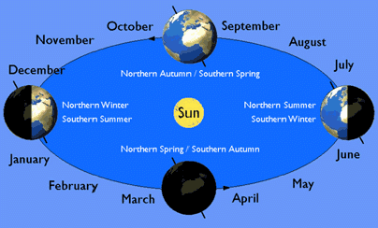
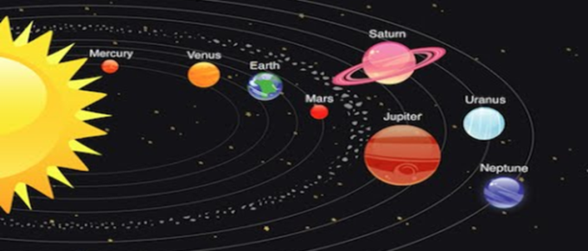
Seasons
Sun appears to move across the sky
Solar system

