Year 5 Class Newsletter: Advent 2
Welcome back after our half term holiday. We hope that you managed to have lots of fun! We just wanted to say well done for all of the wonderful work that you produced, while we were all self-isolating. We were very pleased with the effort that you put in and we know that we will see that same fantastic effort during this half term.
Literacy
We will be using inspiration from our topic work on the Ancient Greeks for much of our literacy work this half term. Inspired by the Battle of Marathon, we will be writing newspaper reports after looking at examples and studying their features. We will also be using Greek recipes to look at instruction writing.
Maths
This half term we will be concentrating on multiplication and division, and their relationship to each other. The following Maths topic will be fractions, decimals and percentages. Please continue to support your child with their times tables knowledge- quick recall is really important, and we will be taking a weekly challenge to speed up their responses.
RE
We are currently looking at ‘Life Choices’ and the calling God has called each of us to. As part of this, we are thinking about the Sacrament of Marriage. After this, we will be reflecting on the meaning of Advent, as we wait for the coming of Jesus at Christmas time.
Science
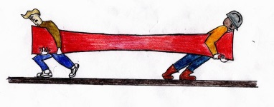
We will be continuing our work on Earth and Space this half term, before exploring forces, including gravity, friction, up thrust and air resistance. We will look at balanced and imbalanced forces and their effects on objects. Please see the key learning sheets for more details.

History
Ancient Greece will continue to be the topic that we study this half term. We will be learning about how the Ancient Greeks have influenced our lives and the legacy of Greek culture on modern Britain.

Computing
We will build upon the children’s knowledge of ‘Scratch’ to design games, using computer programming. This is always a topic that the children really enjoy and we look forward to seeing what they create.

We look forward to an enjoyable, productive and long half term. As always, if you have any concerns, do not hesitate to contact us, either through Class Dojo, or by contacting the school office.
Kind regards,
Mrs. Rice and Mrs. Stachurski

