Ancient Greece
Key vocabulary and definitions

Civilization | A well organised society | Agora | An open space in an ancient Greek city, used as a market and a meeting place.
City State | An independently governed city and its surrounding lands | Chorus | A group of actors who speak together to comment on a play
Democracy | A system of government where leaders are voted for by the people. | Legacy | Something left for future generations
Myths | Traditional Greek stories involving gods and goddesses | Socrates, Aristotle, Plato, Pythagoras | Famous Greeks thinkers
Philosophy | A study of knowledge, truth and human existence | Parthenon | Temple in Athens dedicated to Athena
Athens | The capital of modern Greece and an Ancient Greek city state | Mount Olympus | Home of the gods
Sparta | An ancient Greek city state | Battle of Marathon | Famous Greek battle
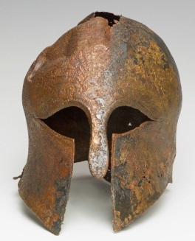
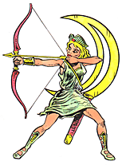
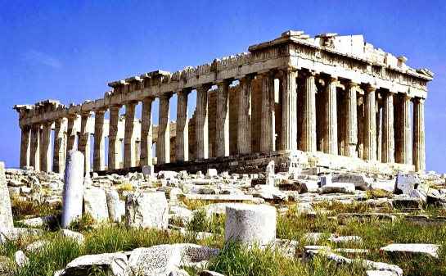

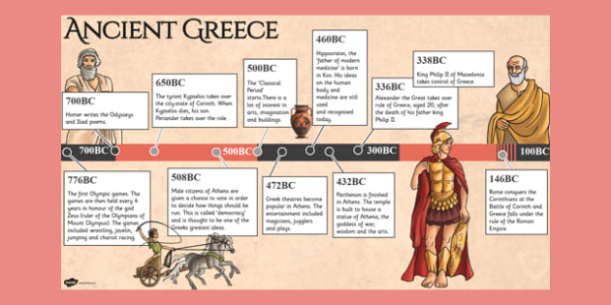
- City States: Athens and Sparta

- Everyday life
- Greek myths and gods and goddesses
- Greek theatre
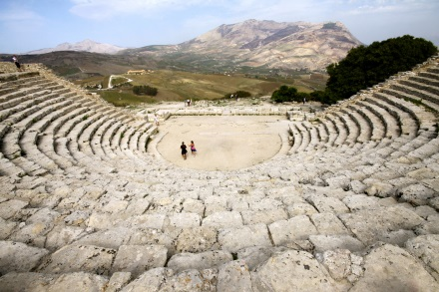
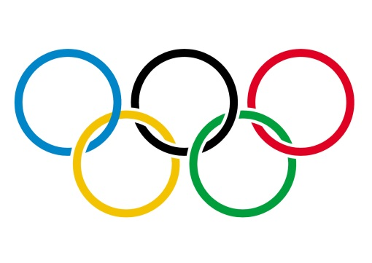
- The Olympic Games
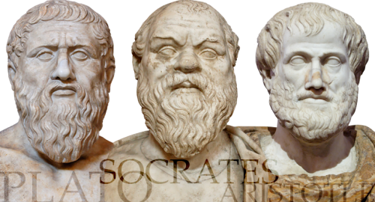
- Writers and thinkers
- The legacy of Ancient Greece

